**Method Design**

**Class Name**: ProductController

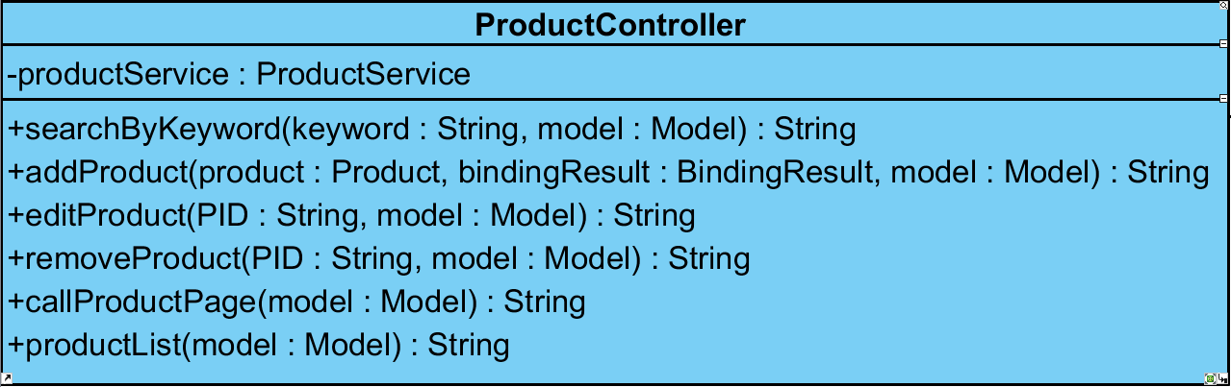

**Method:**

|  |  |  |  |
| --- | --- | --- | --- |
| **ID** | **Name** | **Description** | **Remark** |
| 1 | SearchByKeyword() | This method uses for searching the product by using product’s keyword from database. | **Return Type**: String  **Parameters:** keyword, model |
| 2 | addProduct() | This method uses for adding the product into database. | **Return Type**: String  **Parameters:** product, bindingResult, model |
| 3 | editProduct() | This method uses for editing the details of the product from database. | **Return Type**: String  **Parameters:** PID, model |
| 4 | removeProduct() | This method uses for removing the product from database. | **Return Type**: String  **Parameters:** PID, model |
| 5 | callProductPage() | This method uses for calling the product page from database. | **Return Type**: String  **Parameters:** model |
| 6 | productList() | This method uses for showing the entire of product list from database. | **Return Type**: String  **Parameters:** model |

**Class Name**: ProductService

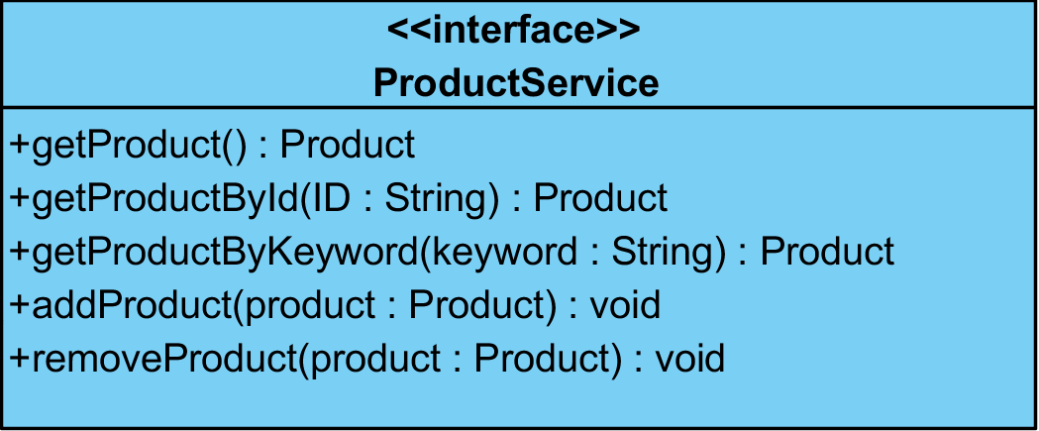

**Method:**

|  |  |  |  |
| --- | --- | --- | --- |
| **ID** | **Name** | **Description** | **Remark** |
| 1 | getProduct() | This method uses for getting the product from database. | **Return Type**: Product  **Parameters:** None |
| 2 | getProductByid() | This method uses for getting the product by using product’s id from database. | **Return Type**: Product  **Parameters:** ID |
| 3 | getProductByKeyword() | This method uses for getting the product by using product’s keyword from database. | **Return Type**: Product  **Parameters:** keyword |
| 4 | addProduct() | This method uses for adding the product and details into database. | **Return Type**: void  **Parameters:** product |
| 5 | removeProduct() | This method uses for removing the product and details from database. | **Return Type**: void  **Parameters:** product |

**Class Name**: ProductServiceImpl

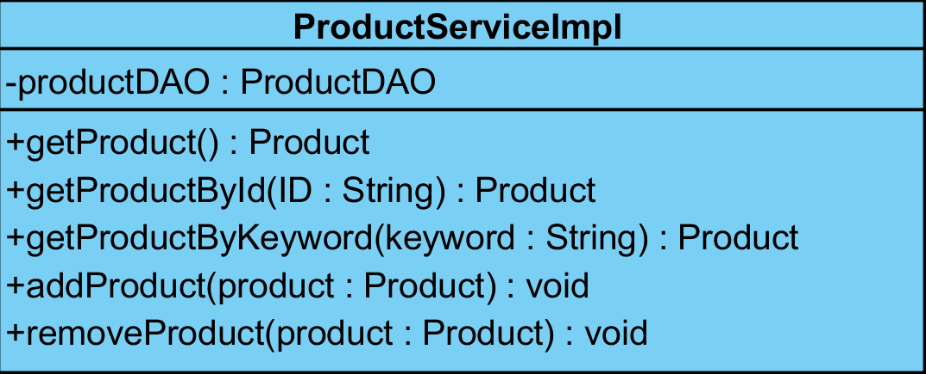

**Method:**

|  |  |  |  |
| --- | --- | --- | --- |
| **ID** | **Name** | **Description** | **Remark** |
| 1 | getProduct() | This method uses for getting the product from database. | **Return Type**: Product  **Parameters:** None |
| 2 | getProductByid() | This method uses for getting the product by using product’s id from database. | **Return Type**: Product  **Parameters:** ID |
| 3 | getProductByKeyword() | This method uses for getting the product by using product’s keyword from database. | **Return Type**: Product  **Parameters:** keyword |
| 4 | addProduct() | This method uses for adding the product and details into database. | **Return Type**: void  **Parameters:** product |
| 5 | removeProduct() | This method uses for removing the product and details from database. | **Return Type**: void  **Parameters:** product |

**Class Name**: ProductDAO

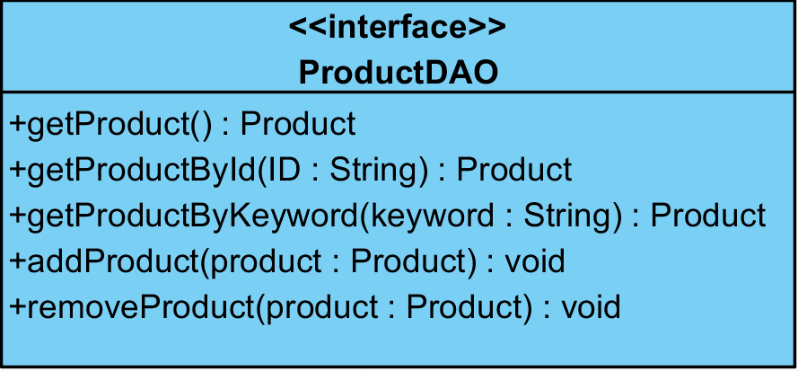

**Method:**

|  |  |  |  |
| --- | --- | --- | --- |
| **ID** | **Name** | **Description** | **Remark** |
| 1 | getProduct() | This method uses for getting the product from database. | **Return Type**: Product  **Parameters:** None |
| 2 | getProductByid() | This method uses for getting the product by using product’s id from database. | **Return Type**: Product  **Parameters:** ID |
| 3 | getProductByKeyword() | This method uses for getting the product by using product’s keyword from database. | **Return Type**: Product  **Parameters:** keyword |
| 4 | addProduct() | This method uses for adding the product and details into database. | **Return Type**: void  **Parameters:** product |
| 5 | removeProduct() | This method uses for removing the product and details from database. | **Return Type**: void  **Parameters:** product |

**Class Name**: ProductDAOImpl

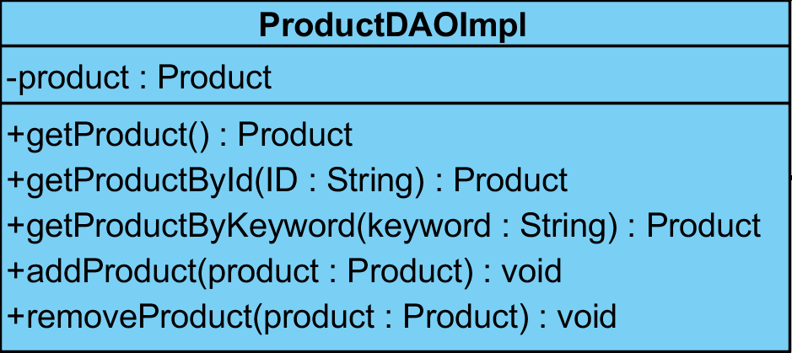

**Method:**

|  |  |  |  |
| --- | --- | --- | --- |
| **ID** | **Name** | **Description** | **Remark** |
| 1 | getProduct() | This method uses for getting the product from database. | **Return Type**: Product  **Parameters:** None |
| 2 | getProductByid() | This method uses for getting the product by using product’s id from database. | **Return Type**: Product  **Parameters:** ID |
| 3 | getProductByKeyword() | This method uses for getting the product by using product’s keyword from database. | **Return Type**: Product  **Parameters:** keyword |
| 4 | addProduct() | This method uses for adding the product and details into database. | **Return Type**: void  **Parameters:** product |
| 5 | removeProduct() | This method uses for removing the product and details from database. | **Return Type**: void  **Parameters:** product |

**Class Name**: ShoppingCart

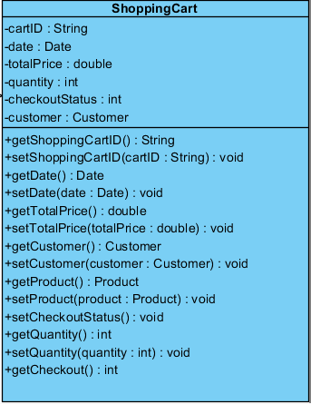

**Method:**

|  |  |  |  |
| --- | --- | --- | --- |
| **ID** | **Name** | **Description** | **Remark** |
| 1 | setCheckoutStatus() | This method uses for setting the checkout status to database. | **Return Type**: void  **Parameters:** None |
| 2 | getCheckout() | This method uses for getting the checkout status from database. | **Return Type**: Int  **Parameters:** None |

**Class Name**: ShoppingCartController

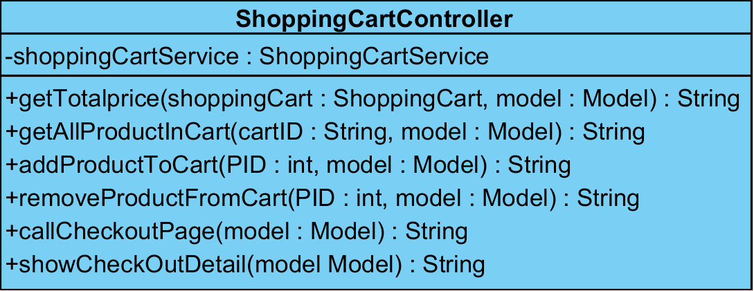

**Method:**

|  |  |  |  |
| --- | --- | --- | --- |
| **ID** | **Name** | **Description** | **Remark** |
| 1 | getTotalPrice() | This method uses for getting the total price of transaction from database. | **Return Type**: String  **Parameters:** shoppingCart, model |
| 2 | getAllProductInCart() | This method uses for getting the entire of product in shopping cart from database. | **Return Type**: String  **Parameters:** cartID, model |
| 3 | addProductToCart() | This method uses for adding the product into shopping cart. | **Return Type**: String  **Parameters:** PID, model |
| 4 | removeProductFromCart() | This method uses for removing the product and details from shopping cart. | **Return Type**: String  **Parameters:** PID, model |
| 5 | callCheckoutPage() | This method uses for calling the checkout page from database. | **Return Type**: String  **Parameters:** model |
| 6 | showCheckOutDeatail() | This method uses for showing the checkout’s details from database. | **Return Type**: String  **Parameters:** model |

**Class Name**: ShoppingCartService

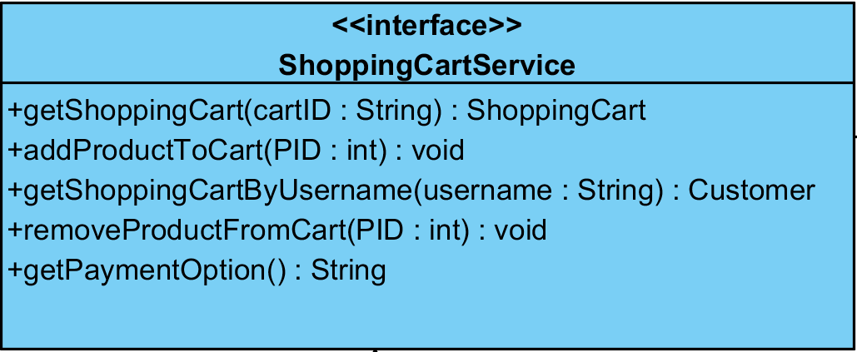

**Method:**

|  |  |  |  |
| --- | --- | --- | --- |
| **ID** | **Name** | **Description** | **Remark** |
| 1 | getShoppingCart() | This method uses for getting the shopping cart from database. | **Return Type**: ShoppingCart  **Parameters:** cartID |
| 2 | getShoppingCartByUsername() | This method uses for getting the shopping cart by using customer’s username from database. | **Return Type**: Customer  **Parameters:** username |
| 3 | addProductToCart() | This method uses for adding the product and quantity into shopping cart. | **Return Type**: void  **Parameters:** PID |
| 4 | removeProductFromCart() | This method uses for removing the product and quantity from shopping cart. | **Return Type**: void  **Parameters:** PID |
| 5 | getPaymentOption() | This method uses for getting the payment option from database. | **Return Type**: String  **Parameters:** None |

**Class Name**: ShoppingCartServiceImpl

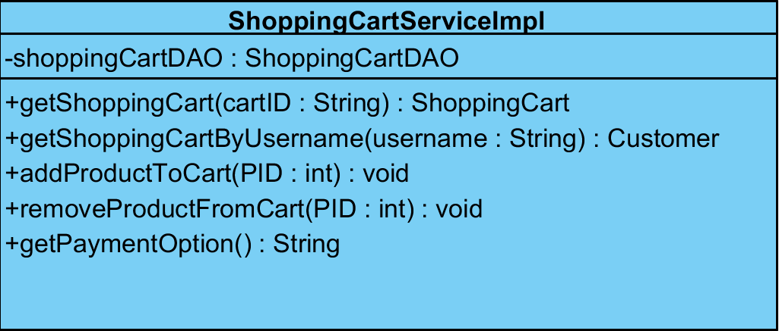

**Method:**

|  |  |  |  |
| --- | --- | --- | --- |
| **ID** | **Name** | **Description** | **Remark** |
| 1 | getShoppingCart() | This method uses for getting the shopping cart from database. | **Return Type**: ShoppingCart  **Parameters:** cartID |
| 2 | getShoppingCartByUsername() | This method uses for getting the shopping cart by using customer’s username from database. | **Return Type**: Customer  **Parameters:** username |
| 3 | addProductToCart() | This method uses for adding the product and quantity into shopping cart. | **Return Type**: void  **Parameters:** PID |
| 4 | removeProductFromCart() | This method uses for removing the product and quantity from shopping cart. | **Return Type**: void  **Parameters:** PID |
| 5 | getPaymentOption() | This method uses for getting the payment option from database. | **Return Type**: String  **Parameters:** None |

**Class Name**: ShoppingCartDAOImpl

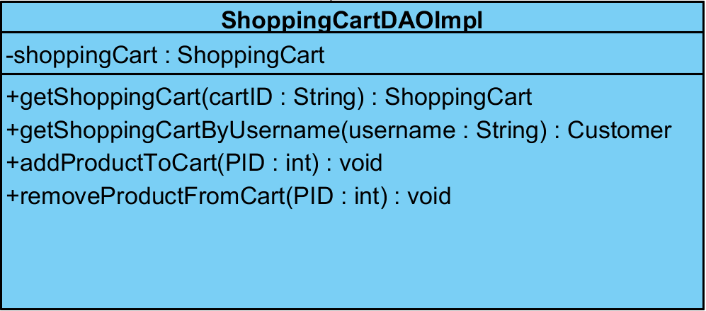

**Method:**

|  |  |  |  |
| --- | --- | --- | --- |
| **ID** | **Name** | **Description** | **Remark** |
| 1 | getShoppingCart() | This method uses for getting the shopping cart from database. | **Return Type**: ShoppingCart  **Parameters:** cartID |
| 2 | getShoppingCartByUsername() | This method uses for getting the shopping cart by using customer’s username from database. | **Return Type**: Customer  **Parameters:** username |
| 3 | addProductToCart() | This method uses for adding the product and quantity into shopping cart. | **Return Type**: void  **Parameters:** PID |
| 4 | removeProductFromCart() | This method uses for removing the product and quantity from shopping cart. | **Return Type**: void  **Parameters:** PID |

**Class Name**: ShoppingCartDAO

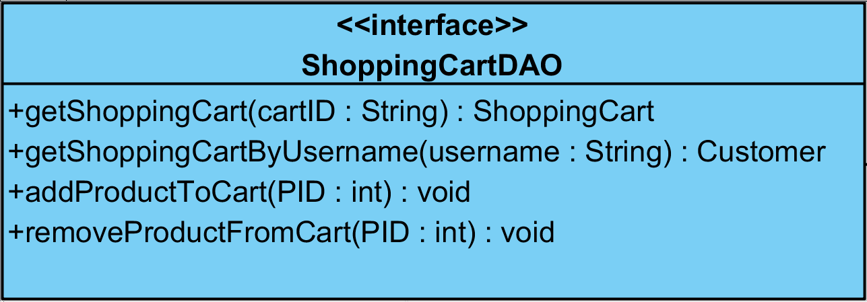

**Method:**

|  |  |  |  |
| --- | --- | --- | --- |
| **ID** | **Name** | **Description** | **Remark** |
| 1 | getShoppingCart() | This method uses for getting the shopping cart from database. | **Return Type**: ShoppingCart  **Parameters:** cartID |
| 2 | getShoppingCartByUsername() | This method uses for getting the shopping cart by using customer’s username from database. | **Return Type**: Customer  **Parameters:** username |
| 3 | addProductToCart() | This method uses for adding the product and quantity into shopping cart. | **Return Type**: void  **Parameters:** PID |
| 4 | removeProductFromCart() | This method uses for removing the product and quantity from shopping cart. | **Return Type**: void  **Parameters:** PID |

**Class Name**: HistoryController

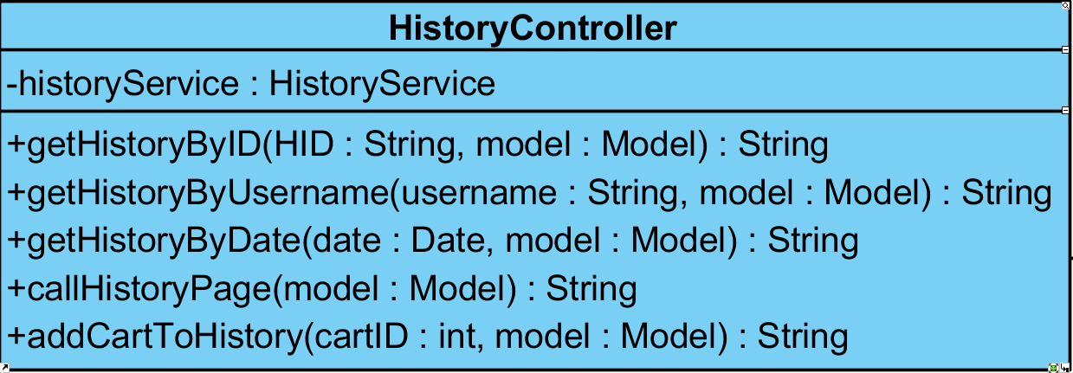

**Method:**

|  |  |  |  |
| --- | --- | --- | --- |
| **ID** | **Name** | **Description** | **Remark** |
| 1 | getHistoryByID() | This method uses for getting the history by using customer’s id from database. | **Return Type**: String  **Parameters:** HID, model |
| 2 | getHistoryByUsername() | This method uses for getting the history by using customer’s username from database. | **Return Type**: String  **Parameters:** username, model |
| 3 | getHistoryByDate() | This method uses for getting the history by using transaction’s date from database. | **Return Type**: String  **Parameters:** date, model |
| 4 | callHistoryPage() | This method uses for calling the history page from database. | **Return Type**: String  **Parameters:** model |
| 5 | addCartToHistory() | This method uses for adding the shopping cart into the history database. | **Return Type**: String  **Parameters:** cartID, model |

**Class Name**: HistoryService

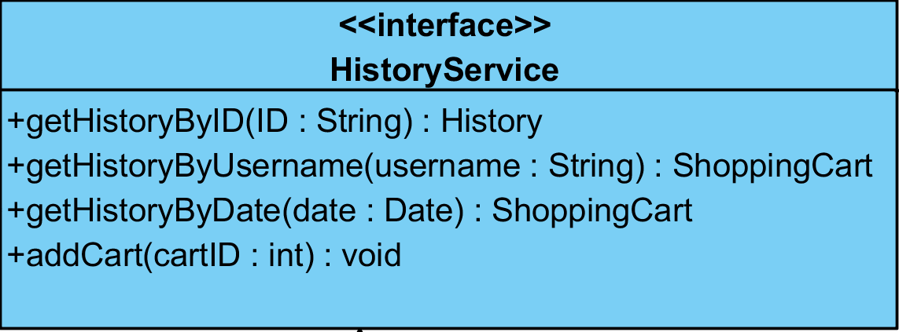

**Method:**

|  |  |  |  |
| --- | --- | --- | --- |
| **ID** | **Name** | **Description** | **Remark** |
| 1 | getHistoryByID() | This method uses for getting the history by using customer’s id from database. | **Return Type**: History  **Parameters:** ID |
| 2 | getHistoryByUsername() | This method uses for getting the history by using customer’s username from database. | **Return Type**: ShoppingCart  **Parameters:** username |
| 3 | getHistoryByDate() | This method uses for getting the history by using transaction’s date from database. | **Return Type**: ShoppingCart  **Parameters:** date |
| 4 | addCart() | This method uses for adding the shopping cart into database. | **Return Type**: void  **Parameters:** cartID |

**Class Name**: HistoryServiceImpl

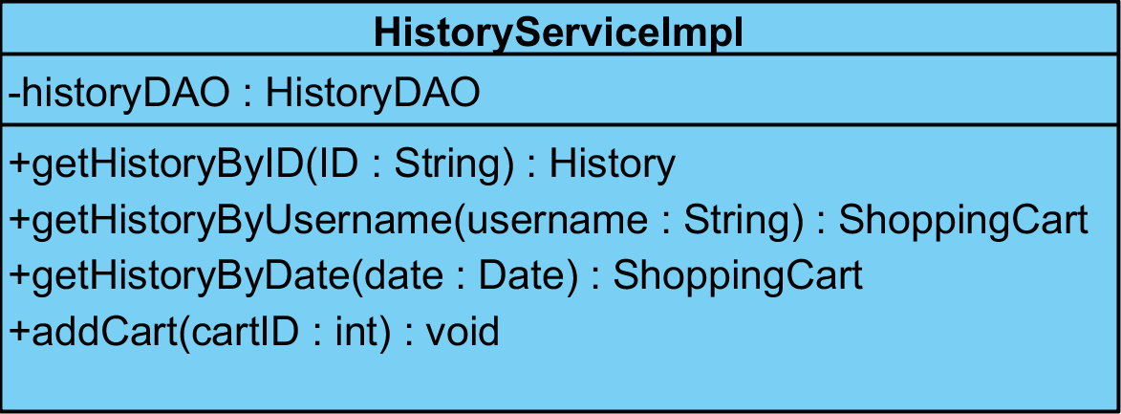

**Method:**

|  |  |  |  |
| --- | --- | --- | --- |
| **ID** | **Name** | **Description** | **Remark** |
| 1 | getHistoryByID() | This method uses for getting the history by using customer’s id from database. | **Return Type**: History  **Parameters:** ID |
| 2 | getHistoryByUsername() | This method uses for getting the history by using customer’s username from database. | **Return Type**: ShoppingCart  **Parameters:** username |
| 3 | getHistoryByDate() | This method uses for getting the history by using transaction’s date from database. | **Return Type**: ShoppingCart  **Parameters:** date |
| 4 | addCart() | This method uses for adding the shopping cart into database. | **Return Type**: void  **Parameters:** cartID |

**Class Name**: HistoryDAO

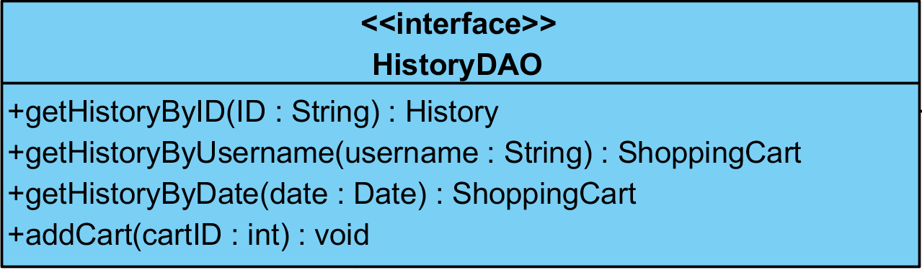

**Method:**

|  |  |  |  |
| --- | --- | --- | --- |
| **ID** | **Name** | **Description** | **Remark** |
| 1 | getHistoryByID() | This method uses for getting the history by using customer’s id from database. | **Return Type**: History  **Parameters:** ID |
| 2 | getHistoryByUsername() | This method uses for getting the history by using customer’s username from database. | **Return Type**: ShoppingCart  **Parameters:** username |
| 3 | getHistoryByDate() | This method uses for getting the history by using transaction’s date from database. | **Return Type**: ShoppingCart  **Parameters:** date |
| 4 | addCart() | This method uses for adding the shopping cart into database. | **Return Type**: void  **Parameters:** cartID |

**Class Name**: HistoryDAOImpl

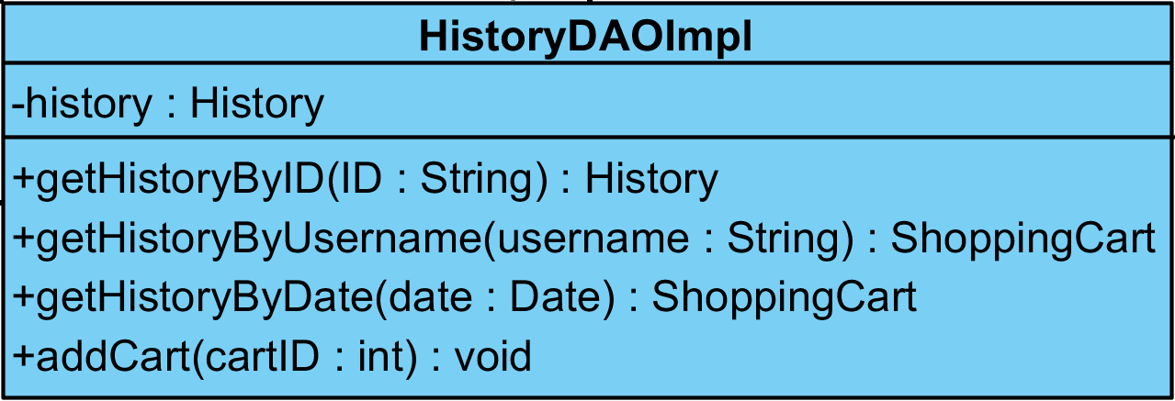

**Method:**

|  |  |  |  |
| --- | --- | --- | --- |
| **ID** | **Name** | **Description** | **Remark** |
| 1 | getHistoryByID() | This method uses for getting the history by using customer’s id from database. | **Return Type**: History  **Parameters:** ID |
| 2 | getHistoryByUsername() | This method uses for getting the history by using customer’s username from database. | **Return Type**: ShoppingCart  **Parameters:** username |
| 3 | getHistoryByDate() | This method uses for getting the history by using transaction’s date from database. | **Return Type**: ShoppingCart  **Parameters:** date |
| 4 | addCart() | This method uses for adding the shopping cart into database. | **Return Type**: void  **Parameters:** cartID |

**Class Name**: Customer

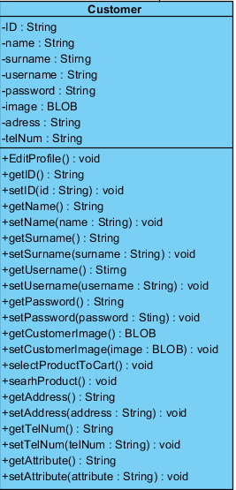

**Method:**

|  |  |  |  |
| --- | --- | --- | --- |
| **ID** | **Name** | **Description** | **Remark** |
| 1 | EditProfile() | This method uses for editing the user’s profile. | **Return Type**: void  **Parameters:** None |

**Class Name**: CustomerController

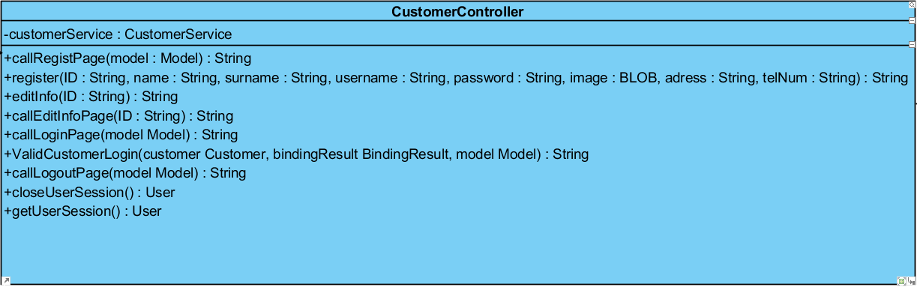

**Method:**

|  |  |  |  |
| --- | --- | --- | --- |
| **ID** | **Name** | **Description** | **Remark** |
| 1 | callRegistPage() | This method uses for calling the registration page from database. | **Return Type**: String  **Parameters:** model |
| 2 | register() | This method uses for registering the new customer into database. | **Return Type**: String  **Parameters:** ID, name, surname, username, password, image, address, telNum |
| 3 | editInfo () | This method uses for editing the customer’s information from database. | **Return Type**: String  **Parameters:** ID |
| 4 | callEditInfoPage () | This method uses for calling the edit information page from database. | **Return Type**: String  **Parameters:** ID |
| 5 | callLoginPage() | This method uses for calling the login page from database. | **Return Type**: String  **Parameters:** model |
| 6 | ValidCustomerLogin() | This method uses for verifying the customer profile through the login. | **Return Type**: String  **Parameters:** customer, bindingResult, model |
| 7 | callLogoutPage() | This method uses for calling the logout page from database. | **Return Type**: String  **Parameters:** model |
| 8 | closeUserSession() | This method uses for finding the close user’s session from database. | **Return Type**: User  **Parameters:** None |
| 9 | getUserSession() | This method uses for getting the user’s session from database. | **Return Type**: User  **Parameters:** None |

**Class Name**: CustomerService

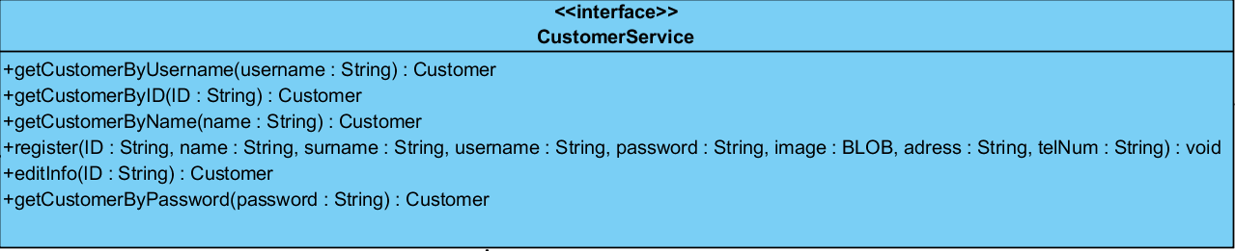

**Method:**

|  |  |  |  |
| --- | --- | --- | --- |
| **ID** | **Name** | **Description** | **Remark** |
| 1 | getCustomerByID() | This method uses for getting the details of customer by using customer’s id from database. | **Return Type**: Customer  **Parameters:** ID |
| 2 | getCustomerByUsername() | This method uses for getting the details of customer by using customer’s username from database. | **Return Type**: Customer  **Parameters:** username |
| 3 | getCustomerByName() | This method uses for getting the details of customer by using customer’s name from database. | **Return Type**: Customer  **Parameters:** name |
| 4 | getCustomerByPassword() | This method uses for getting the details of customer by using customer’s password from database. | **Return Type**: Customer  **Parameters:** password |
| 5 | register() | This method uses for registering the new customer into database. | **Return Type**: void  **Parameters:** ID, name, surname, username, password, image, address, telNum |
| 6 | editInfo () | This method uses for editing the customer’s information from database. | **Return Type**: Customer  **Parameters:** ID |

**Class Name**: CustomerServiceImpl

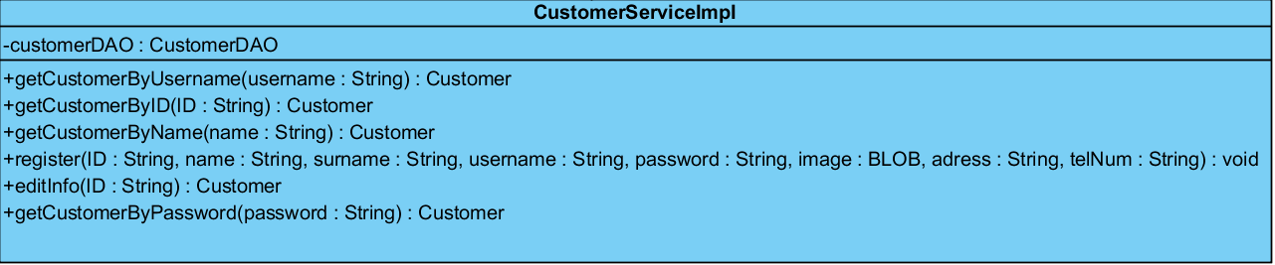

**Method:**

|  |  |  |  |
| --- | --- | --- | --- |
| **ID** | **Name** | **Description** | **Remark** |
| 1 | getCustomerByID() | This method uses for getting the details of customer by using customer’s id from database. | **Return Type**: Customer  **Parameters:** ID |
| 2 | getCustomerByUsername() | This method uses for getting the details of customer by using customer’s username from database. | **Return Type**: Customer  **Parameters:** username |
| 3 | getCustomerByName() | This method uses for getting the details of customer by using customer’s name from database. | **Return Type**: Customer  **Parameters:** name |
| 4 | getCustomerByPassword() | This method uses for getting the details of customer by using customer’s password from database. | **Return Type**: Customer  **Parameters:** password |
| 5 | register() | This method uses for registering the new customer into database. | **Return Type**: void  **Parameters:** ID, name, surname, username, password, image, address, telNum |
| 6 | editInfo () | This method uses for editing the customer’s information from database. | **Return Type**: Customer  **Parameters:** ID |

**Class Name**: CustomerDAO

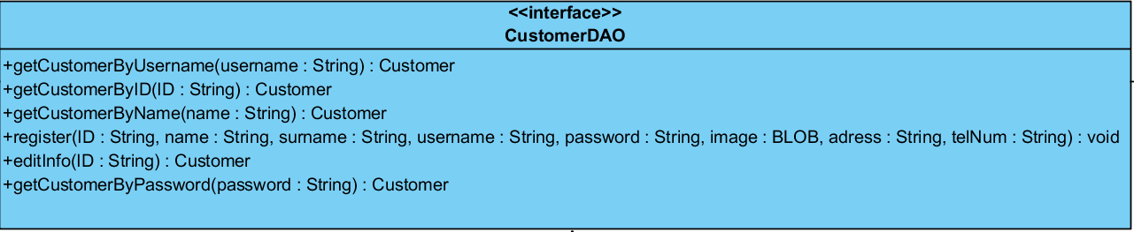

**Method:**

|  |  |  |  |
| --- | --- | --- | --- |
| **ID** | **Name** | **Description** | **Remark** |
| 1 | getCustomerByID() | This method uses for getting the details of customer by using customer’s id from database. | **Return Type**: Customer  **Parameters:** ID |
| 2 | getCustomerByUsername() | This method uses for getting the details of customer by using customer’s username from database. | **Return Type**: Customer  **Parameters:** username |
| 3 | getCustomerByName() | This method uses for getting the details of customer by using customer’s name from database. | **Return Type**: Customer  **Parameters:** name |
| 4 | getCustomerByPassword() | This method uses for getting the details of customer by using customer’s password from database. | **Return Type**: Customer  **Parameters:** password |
| 5 | register() | This method uses for registering the new customer into database. | **Return Type**: void  **Parameters:** ID, name, surname, username, password, image, address, telNum |
| 6 | editInfo () | This method uses for editing the customer’s information from database. | **Return Type**: Customer  **Parameters:** ID |

**Class Name**: CustomerDAOImpl

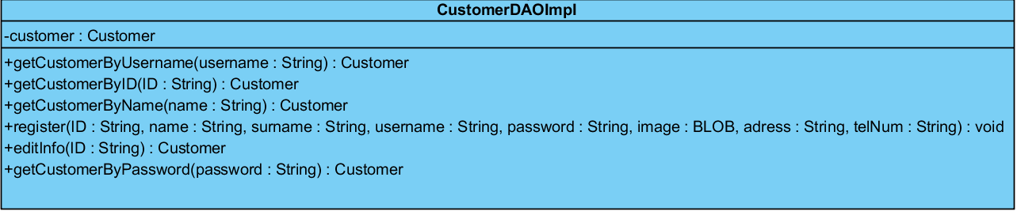

**Method:**

|  |  |  |  |
| --- | --- | --- | --- |
| **ID** | **Name** | **Description** | **Remark** |
| 1 | getCustomerByID() | This method uses for getting the details of customer by using customer’s id from database. | **Return Type**: Customer  **Parameters:** ID |
| 2 | getCustomerByUsername() | This method uses for getting the details of customer by using customer’s username from database. | **Return Type**: Customer  **Parameters:** username |
| 3 | getCustomerByName() | This method uses for getting the details of customer by using customer’s name from database. | **Return Type**: Customer  **Parameters:** name |
| 4 | getCustomerByPassword() | This method uses for getting the details of customer by using customer’s password from database. | **Return Type**: Customer  **Parameters:** password |
| 5 | register() | This method uses for registering the new customer into database. | **Return Type**: void  **Parameters:** ID, name, surname, username, password, image, address, telNum |
| 6 | editInfo () | This method uses for editing the customer’s information from database. | **Return Type**: Customer  **Parameters:** ID |

**Class Name**: Admin

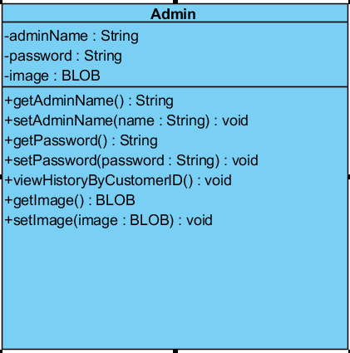

**Method:**

|  |  |  |  |
| --- | --- | --- | --- |
| **ID** | **Name** | **Description** | **Remark** |
| 1 | ViewHistoryByCustomerID() | This method uses for viewing the customer’s history by using customer’s id from database. | **Return Type**: void  **Parameters:** None |

**Class Name**: AdminController

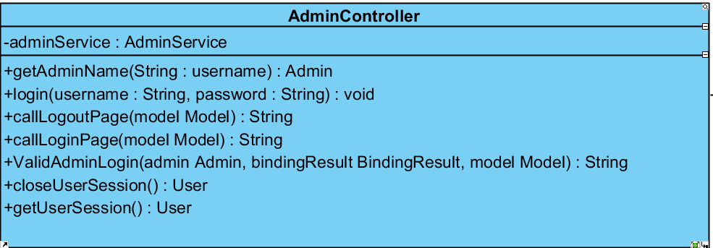

**Method:**

|  |  |  |  |
| --- | --- | --- | --- |
| **ID** | **Name** | **Description** | **Remark** |
| 1 | getAdminName() | This method uses for getting the name of admin from database. | **Return Type**: Admin  **Parameters:** username |
| 2 | login() | This method uses for logging in to the system. | **Return Type**: void  **Parameters:** username**,** password |
| 3 | callLoginPage() | This method uses for calling the login page from database. | **Return Type**: String  **Parameters:** model |
| 4 | callLogoutPage() | This method uses for calling the logout page from database. | **Return Type**: String  **Parameters:** model |
| 5 | ValidAdminLogin() | This method uses for verifying the admin profile through the login. | **Return Type**: String  **Parameters:** customer, bindingResult, model |
| 6 | closeUserSession() | This method uses for finding the close user’s session from database. | **Return Type**: User  **Parameters:** None |
| 7 | getUserSession() | This method uses for getting the user’s session from database. | **Return Type**: User  **Parameters:** None |

**Class Name**: AdminService

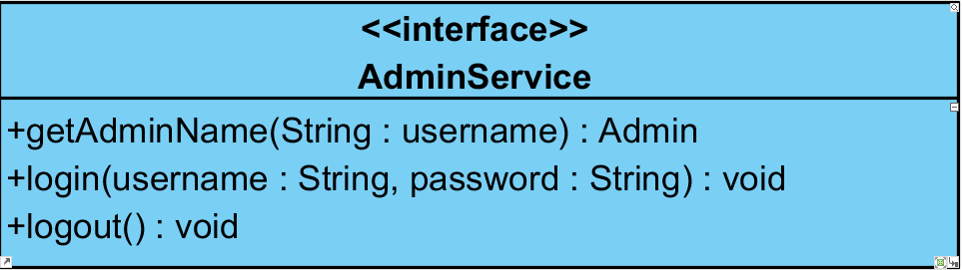

**Method:**

|  |  |  |  |
| --- | --- | --- | --- |
| **ID** | **Name** | **Description** | **Remark** |
| 1 | getAdminName() | This method uses for getting the name of admin from database. | **Return Type**: Admin  **Parameters:** username |
| 2 | login() | This method uses for logging in to the system. | **Return Type**: void  **Parameters:** username**,** password |
| 3 | logout() | This method uses for logging out from the system. | **Return Type**: void  **Parameters:** None |

**Class Name**: AdminServiceImpl

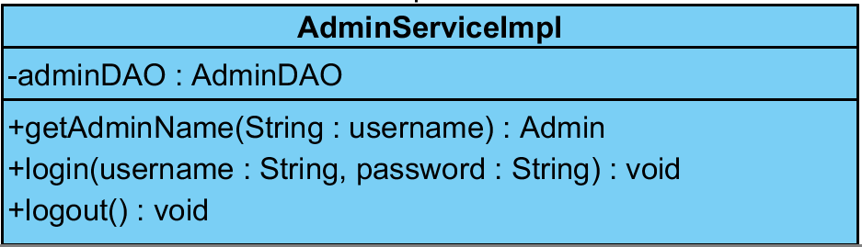

**Method:**

|  |  |  |  |
| --- | --- | --- | --- |
| **ID** | **Name** | **Description** | **Remark** |
| 1 | getAdminName() | This method uses for getting the name of admin from database. | **Return Type**: Admin  **Parameters:** username |
| 2 | login() | This method uses for logging in to the system. | **Return Type**: void  **Parameters:** username**,** password |
| 3 | logout() | This method uses for logging out from the system. | **Return Type**: void  **Parameters:** None |

**Class Name**: AdminDAO

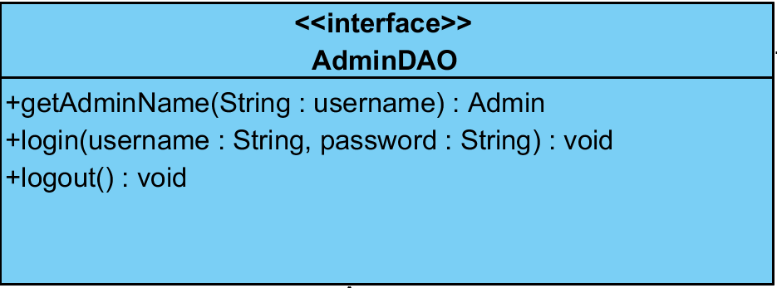

**Method:**

|  |  |  |  |
| --- | --- | --- | --- |
| **ID** | **Name** | **Description** | **Remark** |
| 1 | getAdminName() | This method uses for getting the name of admin from database. | **Return Type**: Admin  **Parameters:** username |
| 2 | login() | This method uses for logging in to the system. | **Return Type**: void  **Parameters:** username**,** password |
| 3 | logout() | This method uses for logging out from the system. | **Return Type**: void  **Parameters:** None |

**Class Name**: AdminDAOImpl

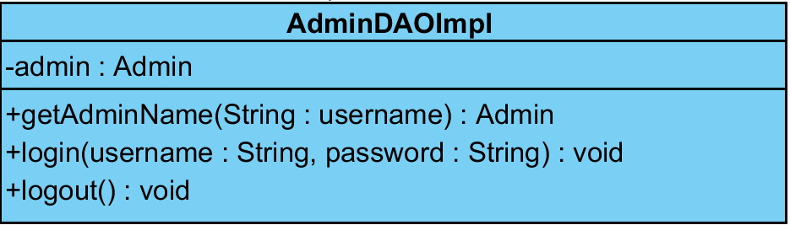

**Method:**

|  |  |  |  |
| --- | --- | --- | --- |
| **ID** | **Name** | **Description** | **Remark** |
| 1 | getAdminName() | This method uses for getting the name of admin from database. | **Return Type**: Admin  **Parameters:** username |
| 2 | login() | This method uses for logging in to the system. | **Return Type**: void  **Parameters:** username**,** password |
| 3 | logout() | This method uses for logging out from the system. | **Return Type**: void  **Parameters:** None |